* **INSTALL selenium**

**pip install selenium**

**OR**

Go through below steps if you are not able to install through pip.

Download tar.gz file form below path

* <https://pypi.org/project/selenium/#files>
* Click on tar.gz file to download

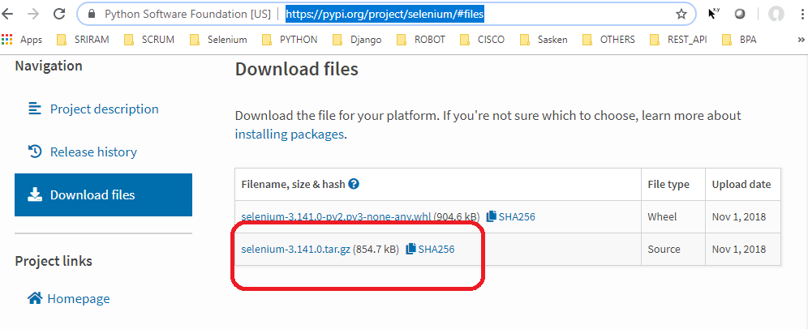

* UNZIP selenium-3.141.0.tar file after downloading.
* After unzipping you will see below files

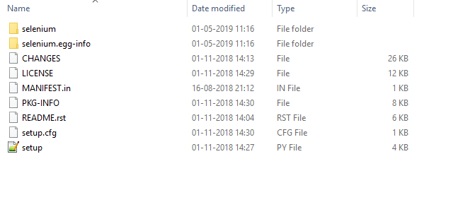

* Then run this command :- **python setup.py install**
* To Check selenium installed or not

**Import selenium**

* To know selenium version

**Import selenium**

Print(selenium.__version__)

* **URL to download chrome Driver**

<https://chromedriver.storage.googleapis.com/index.html>